# **CTF Topic: OSINT Image Metadata**



# **1. Introduction**

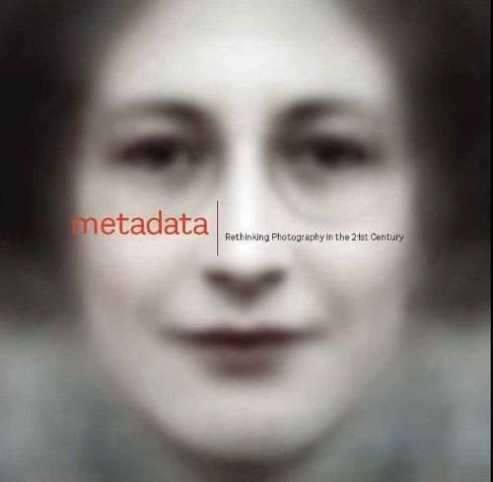

OSINT (Open Source Intelligence) involves gathering information from publicly available sources to gain insights and intelligence. In this Capture the Flag (CTF) challenge, you will use OSINT techniques to extract specific information from the metadata of an image.

# **2. Tools and requirements**

* metadata2go Website
* Image File

# **3. Scenario**



You are conducting an investigation and come across an image related to a suspicious individual. Your task is to extract metadata from the image to gather information that may help identify or provide insights about the person in the image.

# **4. Process to Perform while performing CTF**

**Step 1:** Click on the provided link to download the target image to your computer: <https://www.mediafire.com/file/jhdc9g2gz58x9p0/Anonymous+hacker+in+red+jacket+with+dark+hidden+fa+(1).jpg/file>

**Step 2:** And access the [Metadata2go](https://www.metadata2go.com/view-metadata) website.

**Step 3:** Solve the CTF.

# **Let’s start the Challenge**

# **6. Question**

Flag1: What is the encoding process of Image?

Answer: Progressive DCT, Huffman coding

Flag 2: How many bits per sample are there?

Answer: 8

**7. Hint**

